Name: Samiha Nurin

Id:2025-2-60-237

Project Title: Hangman Game in C

Project Description:
The Hangman Game is a classic word guessing game where the player is given a hint and must guess the word by suggesting letters within a certain number of tries. The game progresses with the player guessing one letter at a time. If the guessed letter is correct, it appears in the word; if incorrect, the player loses one of their limited tries. The goal is to guess the word before running out of tries. In this project, a simple implementation of the Hangman game is created using the C programming language.
The game uses a random selection of simple words (like "cat", "dog", etc.) and provides hints for each word. It also tracks the player's incorrect guesses and displays a simple hangman figure after each incorrect guess.

Project Methodology:
- Random Word Selection:
  - The game randomly selects a word from a predefined list of easy words using the rand() function in C.
- User Input:
  - The player is prompted to input a letter. The input is checked for correctness and whether it has been guessed before.
- Game Logic:
  - If the letter is correct, it is revealed in the word.
  - If the letter is incorrect, the player loses one try, and the hangman figure progresses.
- Word and Hint Display:
  - The program displays the current state of the word with correctly guessed letters shown, and underscores for remaining letters.
  - A hint is provided at the start of the game to help the player.
- Game Termination:
  - The game continues until the player either guesses the word correctly or runs out of tries. If the player guesses the word, they win, otherwise, they lose and the word is revealed.

Code:
#include <ctype.h>
#include <stdbool.h>
#include <stdio.h>
#include <stdlib.h>
#include <string.h>
#include <time.h>

#define MAX_WORD_LENGTH 50
// You get 6 wrong tries: head(1), body(2), left arm(3), right arm(4), left leg(5), right leg(6)
#define MAX_TRIES 6 // wrong tries allowed (0..6 stages shown; stage 6 = lose)

typedef struct {
char word[MAX_WORD_LENGTH];
char hint[MAX_WORD_LENGTH];
} WordWithHint;

/* Multi-line ASCII pictures for each stage (0..6) */
static void drawHangman(int wrongTries) {
static const char* STAGES[7] = {
/* 0: scaffold only */
" _________\n"
" | |\n"
" | \n"
" | \n"
" | \n"
" | \n"
"__|__ \n",

/* 1: head */
" _________\n"
" | |\n"
" | O\n"
" | \n"
" | \n"
" | \n"
"__|__ \n",

/* 2: head + body */
" _________\n"
" | |\n"
" | O\n"
" | |\n"
" | |\n"
" | \n"
"__|__ \n",

/* 3: head + body + left arm */
" _________\n"
" | |\n"
" | O\n"
" | /|\n"
" | |\n"
" | \n"
"__|__ \n",

/* 4: head + body + both arms */
" _________\n"
" | |\n"
" | O\n"
" | /|\\\n"
" | |\n"
" | \n"
"__|__ \n",

/* 5: add left leg */
" _________\n"
" | |\n"
" | O\n"
" | /|\\\n"
" | |\n"
" | / \n"
"__|__ \n",

/* 6: both legs (final/lose) */
" _________\n"
" | |\n"
" | O\n"
" | /|\\\n"
" | |\n"
" | / \\\n"
"__|__ \n"
};

if (wrongTries < 0) wrongTries = 0;
if (wrongTries > 6) wrongTries = 6;
printf("%s", STAGES[wrongTries]);
}

static void showState(const char guessedWord[],
const bool guessedLetters[26],
int wrongTries,
const char* hint) {
printf("\nHint: %s\n", hint);

printf("Word: ");
for (int i = 0; guessedWord[i] != '\0'; i++) {
printf("%c ", guessedWord[i]);
}
printf("\n");

printf("Tried letters: ");
for (int i = 0; i < 26; i++) {
if (guessedLetters[i]) printf("%c ", 'a' + i);
}
printf("\n");

drawHangman(wrongTries);
printf("Tries left: %d\n", MAX_TRIES - wrongTries);
}

/* Safely read a single alphabetic character from a line of input. */
static char readGuess(void) {
char buffer[128];
if (!fgets(buffer, sizeof(buffer), stdin)) {
return '\0';
}
for (int i = 0; buffer[i] != '\0'; i++) {
if (isalpha((unsigned char)buffer[i])) {
return (char)tolower((unsigned char)buffer[i]);
}
}
return '\0'; // no alphabetic character found
}

int main(void) {
srand((unsigned)time(NULL));

// Word list with hints (easy)
WordWithHint words[] = {
{"cat", "A small domesticated animal"},
{"dog", "A loyal companion animal"},
{"apple", "A popular fruit"},
{"sun", "The star at the center of our solar system"},
{"car", "A four-wheeled vehicle"},
{"ball", "A round object used in many games"},
{"book", "A set of written or printed pages"},
{"house", "A building for human habitation"},
{"fish", "A cold-blooded aquatic animal"}
};
int totalWords = (int)(sizeof(words) / sizeof(words[0]));
int chosen = rand() % totalWords;

const char* secret = words[chosen].word;
const char* hint = words[chosen].hint;

size_t n = strlen(secret);

char guessedWord[MAX_WORD_LENGTH];
bool guessedLetters[26] = {false};

// Initialize the guessed word with underscores
for (size_t i = 0; i < n; i++) guessedWord[i] = '_';
guessedWord[n] = '\0';

printf("=== Welcome to Hangman! ===\n");

int wrongTries = 0;
while (wrongTries <= MAX_TRIES) {
showState(guessedWord, guessedLetters, wrongTries, hint);

// Win check before asking (covers case of zero-length or already guessed)
if (strcmp(secret, guessedWord) == 0) {
printf("\n🎉 Congratulations! You guessed the word: %s\n", secret);
return 0;
}

if (wrongTries == MAX_TRIES) break; // reached final stage

printf("Enter a letter (A-Z): ");
char guess = readGuess();
if (guess == '\0') {
printf("Please enter a valid letter A-Z.\n");
continue;
}

int idx = guess - 'a';
if (idx < 0 || idx >= 26) {
printf("Please enter a letter A-Z.\n");
continue;
}

if (guessedLetters[idx]) {
printf("You've already guessed '%c'. Try another letter.\n", guess);
continue;
}
guessedLetters[idx] = true;

// Reveal the letter if present
bool found = false;
for (size_t i = 0; i < n; i++) {
if (secret[i] == guess) {
guessedWord[i] = guess;
found = true;
}
}

if (found) {
printf("Good guess!\n");
} else {
printf("Sorry, '%c' is not in the word.\n", guess);
wrongTries++;
}
}

// Lose condition
showState(guessedWord, guessedLetters, wrongTries, hint);
printf("\n💀 Out of tries! The word was: %s\n", secret);
return 0;
}

Output:

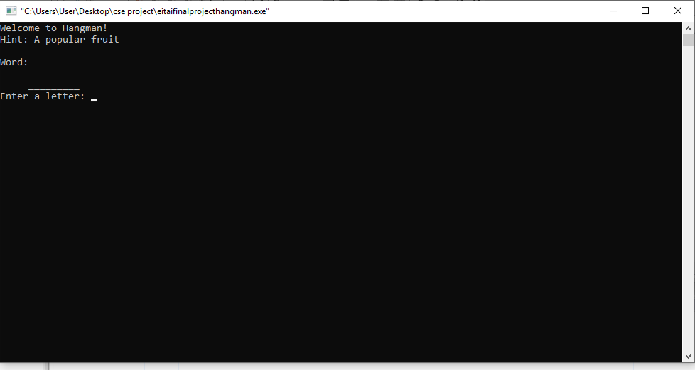

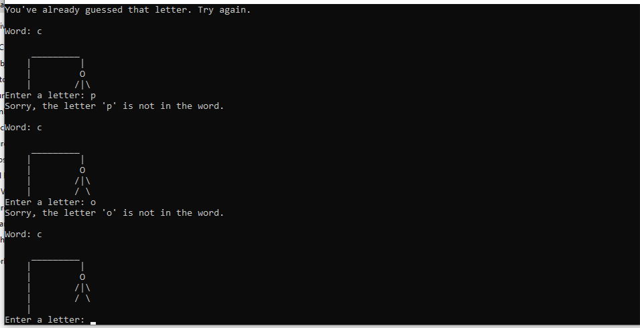

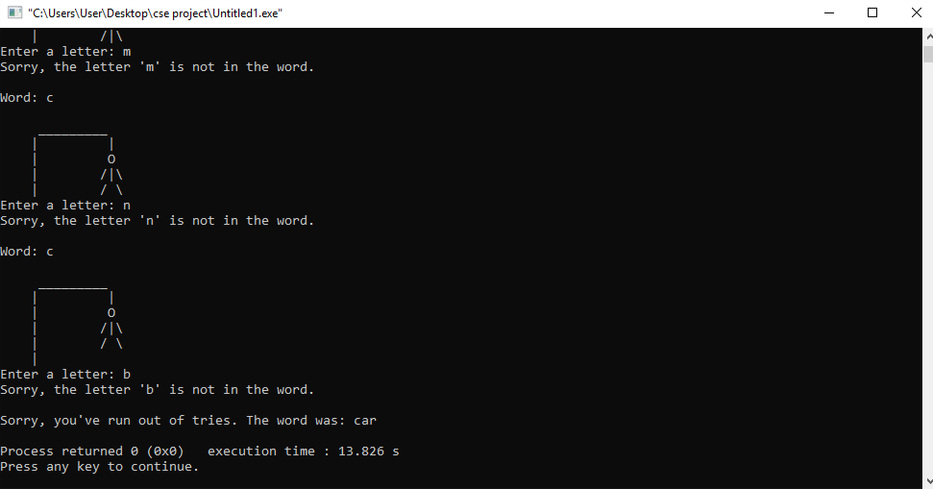

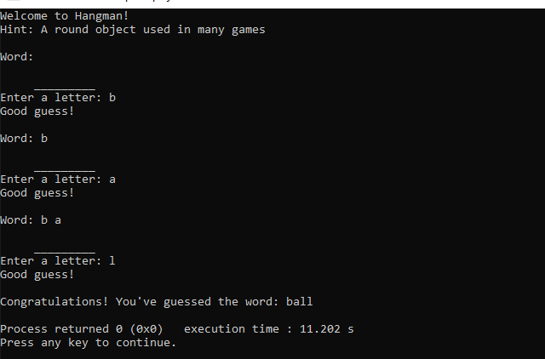

Conclusion:
The Hangman project successfully demonstrates the use of fundamental C programming concepts such as arrays, structures, string handling, loops, conditional statements, and functions. By integrating features like hints, tracking of guessed letters, and visual representation of the hangman, the game provides both an educational and entertaining experience for the user.
This project highlights the importance of problem-solving skills in programming, as it required careful planning to manage word selection, handle repeated guesses, and update the game state dynamically. It also shows how modular design—through the use of separate functions like displayWord() and drawHangman()—improves readability and reusability of code.
Overall, the project not only reinforces key C programming concepts but also demonstrates how these concepts can be applied to build an interactive game. It serves as a strong foundation for further improvements, such as expanding the word list, adding difficulty levels, or implementing a graphical user interface. In the future, the game can be enhanced with a larger word database, difficulty levels, and graphical UI using libraries."

